**State wise created reports**

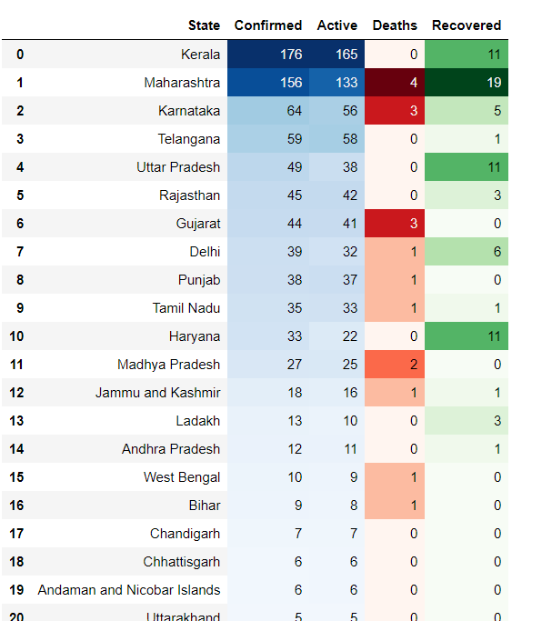

**State wise Confirmed and Deaths w.r.t dates**

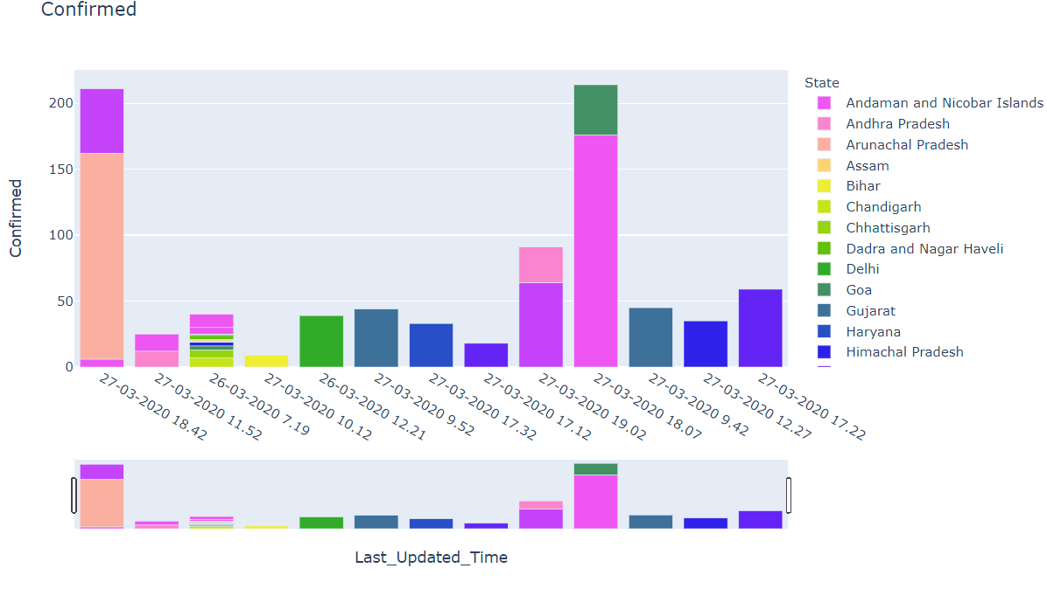

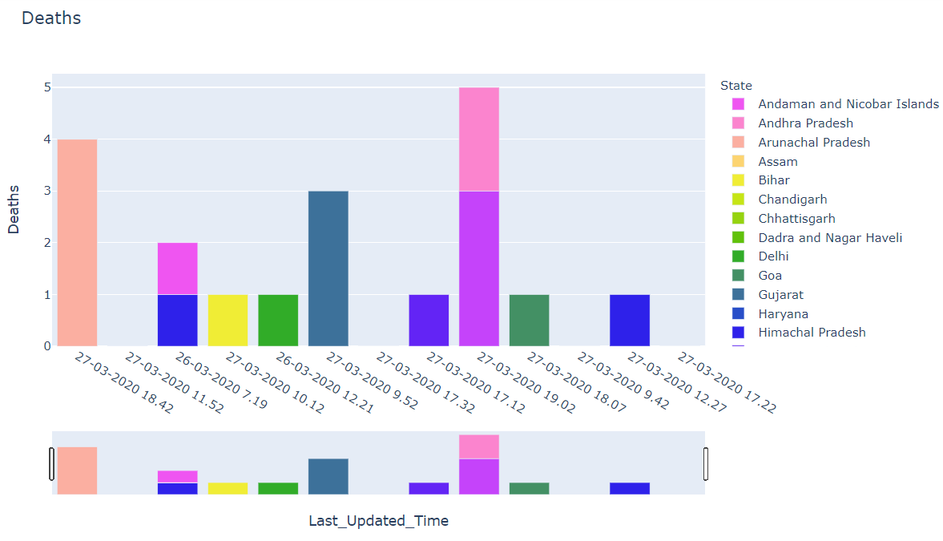

**Donut plot of total Active, Recovered and Deaths**

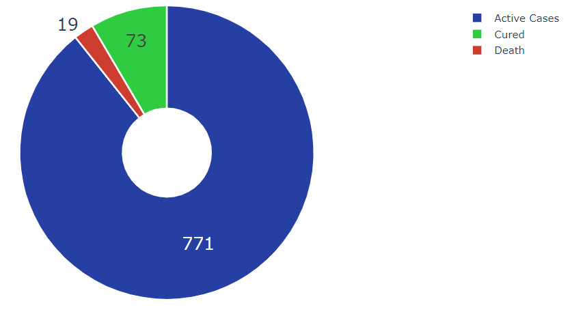

**Trend of Weekly Corona virus Cases in India**

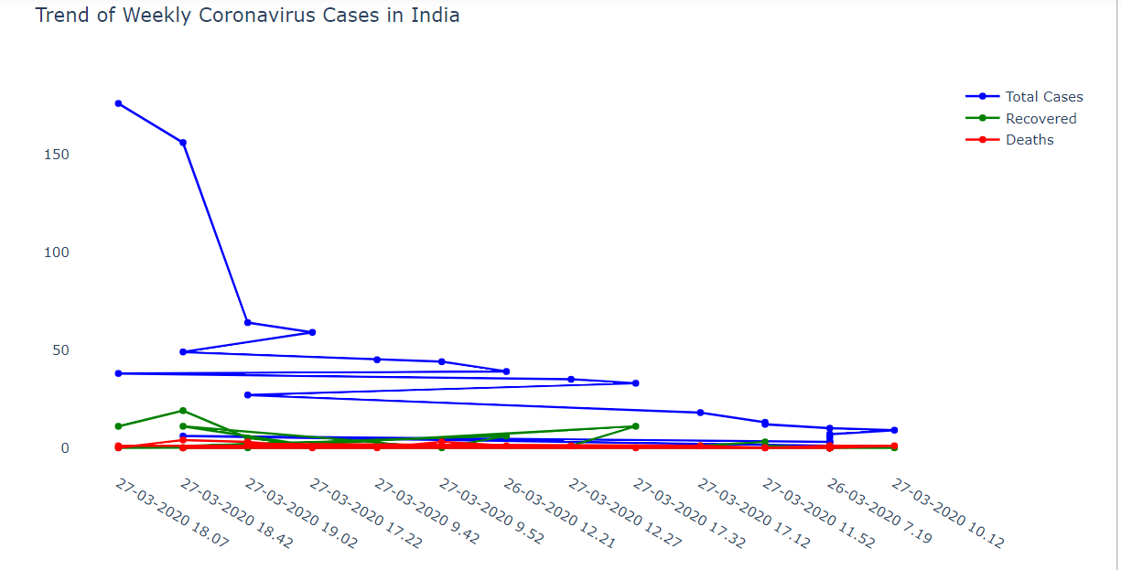

**Visualization on Map**

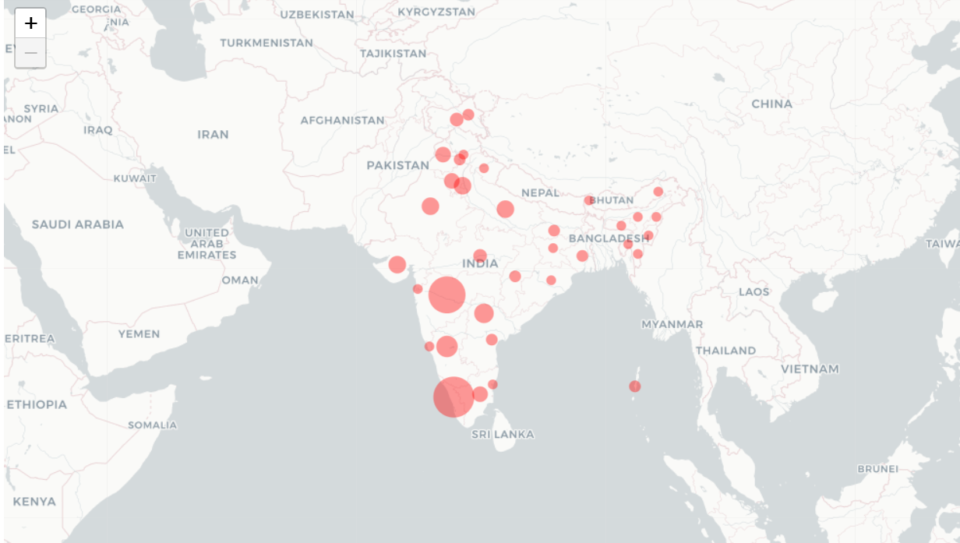

**Tree Map shows State having Confirmed cases**

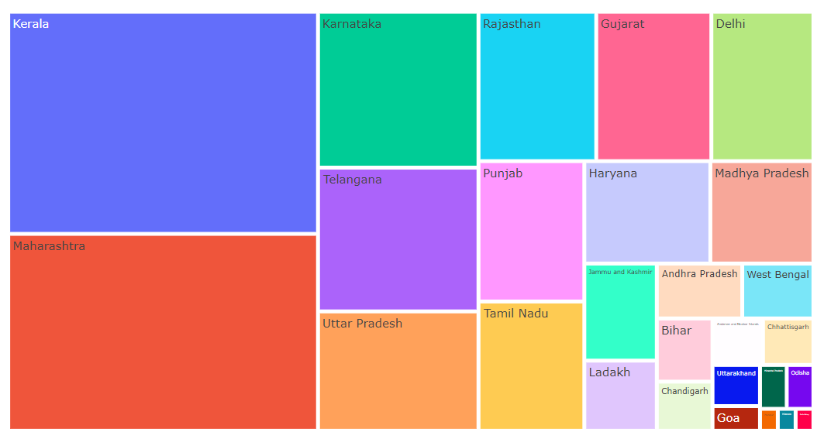

**Pie plot showing Active cases w.r.t States**

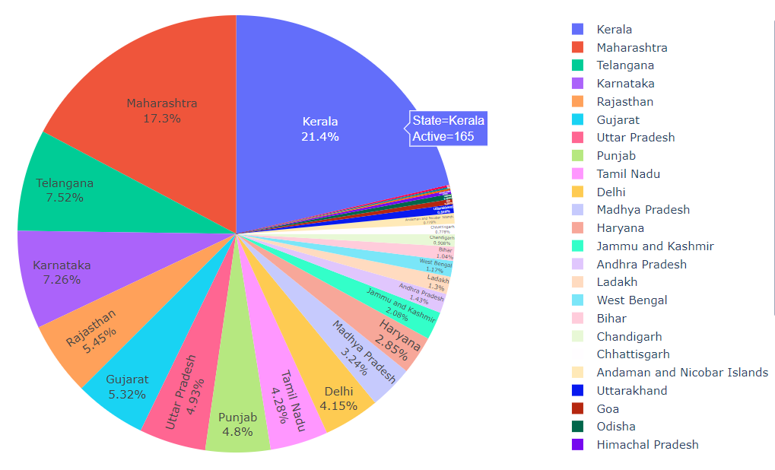

**Bar plot of State showing Confirmed, Recovered and Deaths cases**

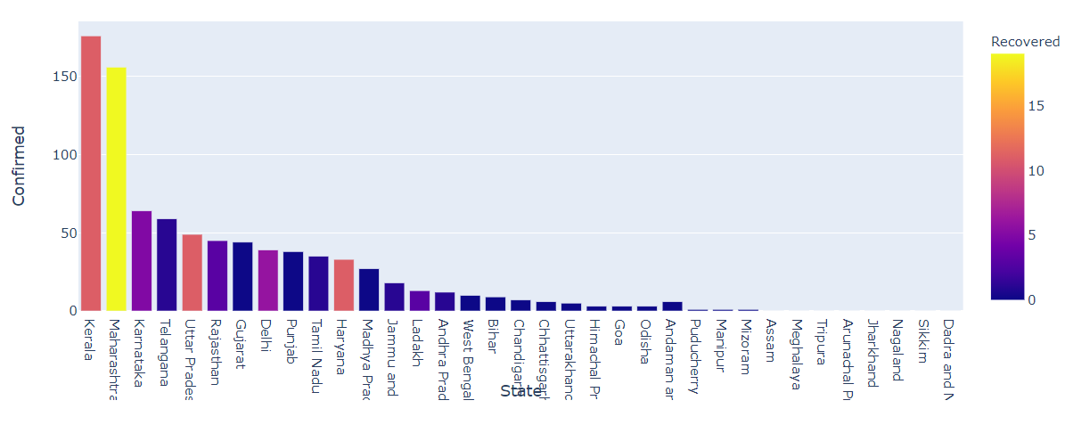

# Sunburst plot

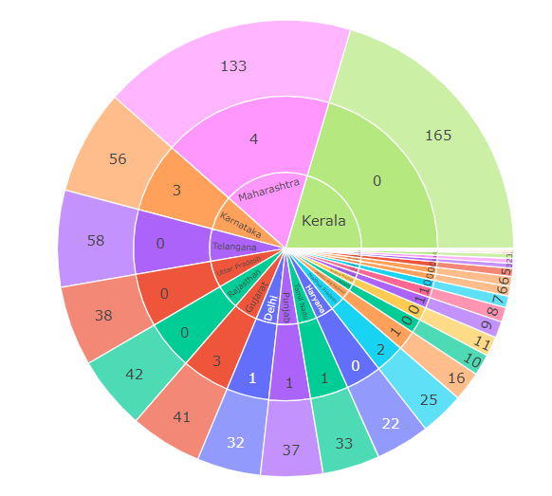

# Spread Chart Showing Deaths and Confirmed cases

# 

# Rose graph / Bar Polar Graph shows Active, Deaths, Recovered cases w.r.t States

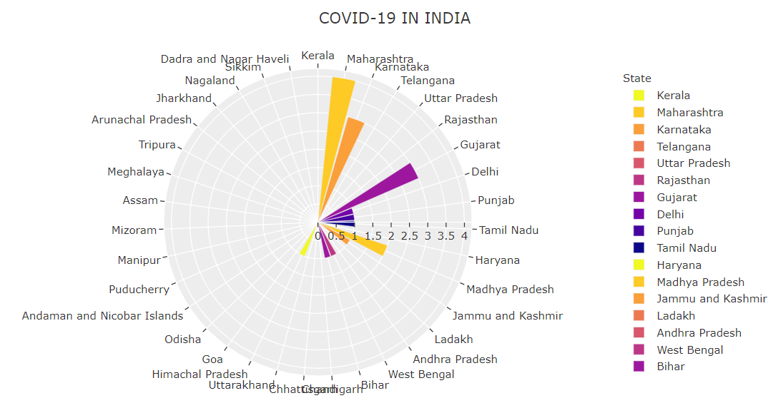

**Funnel area chart shows State Vs Recovered cases**

